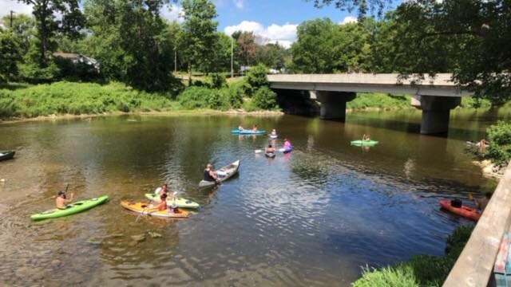  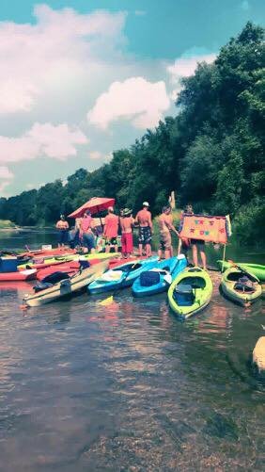  2nd Annual Kayak for a Concert  Handmade Music Festival Fundraiser  WHEN: SATURDAY, JULY 13TH, 2019  Starts at 10 AM – 3pm (tubes/rafts 2pm) with launches/flights every 30 min.  WHERE: PARSHALLBURG TO SHOWBOAT PARK  Drop your ‘yaks, cooler and kin at Parshallburg, drive your vehicle to Showboat Park, park it and hop a shuttle back to launch!  COST: $25/PERSON INCLUDES LUNCH at SHOWBOAT PARK  Join us as we enjoy the Shiawassee River! This float will launch from Parshallburg kayak/canoe launch site (south of the old dam) starting at 10am and travel to Showboat Park, where we will have a picnic style pig roast with all the fixings. Along this beautiful stretch of the river we will have a fun scavenger hunt plus a few pitstops. Proceeds will help the Handmade Music Festival, September 27th & 28th, 2019!  Registration is required. Pre-registration is encouraged.  Full Name ________________________________________  Address__________________________________________  City, State & Zip__________________________________________  Email____________________________________________  Cell (text rates may apply) ___________ Phone_______________  Make checks payable to Handmade Music Festival and mail to:  308 N Main St  Chesaning, MI 48616  or pay online via PayPal to handmademusicfestival@gmail.com.  If paying by PayPal, in the “NOTES” section, please list the names of those included in payment.  All registrants will need to fill out a liability waiver before participating in the paddle. | Give-A-Ways!  SCAVENGER HUNT!  ────  RAFFLE DRAWING!  1ST PLACE – $500 CASH  2ND PLACE – $250 CASH  3RD PLACE – $100 CASH  TICKETS ARE $5/EA OR 5/$20  LICENSE #R53615  ────  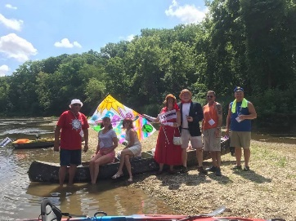  Tires for Tickets!  Bring us tires, bikes and whatever else doesn’t belong in the Shiawassee River and receive a  FREE TICKET TO HMMF 2019!  